CURRICULUM VITAE

PERSONAL DETAILS
Name: Vũ Đức Thắng | Sex: Male | 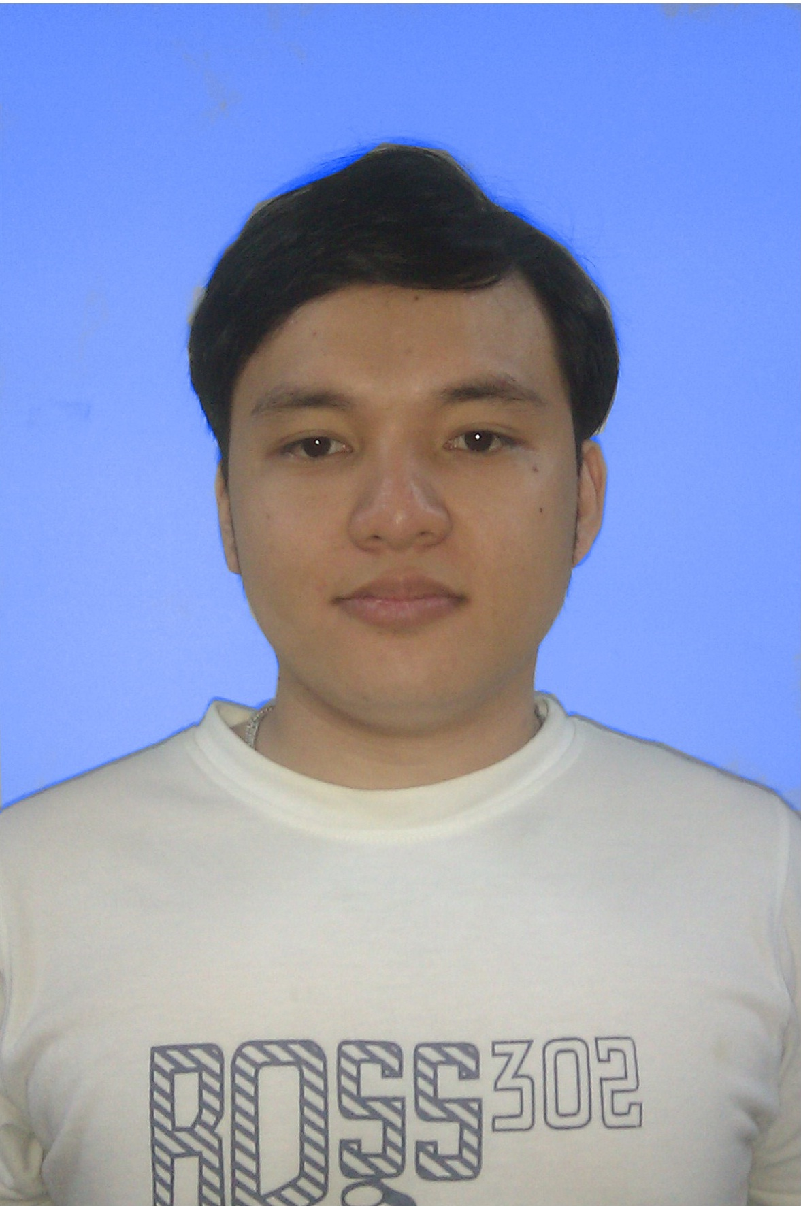
Date of birth: January 8th, 1990 | Natioality: Vietnamese
Email: Thangvdmaster@gmail.com or Thangvd60124@fpt.edu.vn | Mobile: 01669004447 or 0839840728
Address: E13 NGuyễn Văn Lượng Street, Gò Vấp District – Hồ Chí Minh City
Brief Professional Information:
- Strong in C , Java, assembly…
- Have an inquiring mind
- Communication, negotiation, presentation skills
- Ability to work under pressure and meet tight deadlines
- Have a high sense of responsibility
- Be willing to work at weekends due to urgent tasks
- Spoken and written English a little

LANGUAGES (1: begin, 5: expert) | 1 | 2 | 3 | 4 | 5 | Score (TOEFL, TOEIC, etc.)
Vietnamese |  |  |  | x
English |  |  | x |  |  | TOEFL = 550
Japanese | x

EDUCATION, ACHIEVEMENTS
2005 – 2008 | Gia Định High School
2008 - 2012 | FPT University

TECHNICAL SKILLS (Order by experience/level, from High to Low)
OS | Windows, linux
Languages | C/C++, Java, Assembly, HTML, SQL, C#
Databases | SQL Server, MySQL, DB2
Software Packages | .NET Framework, J2SE, Microsoft Office, MathLab
Methodologies/Tools | MPLAB, NetBean IDE ,Eclipse, Visual Studio, Dev C++

RECENT PROJECTS
Project | JAMP2 - JAL Infotec
Duration | 15/03~20/8/2011
Size | About 30 man-months
Position | Developer, Tester
Project Description | The project is the management system for JAV Infotech customer
Technologies | Java, struts 2, DB2
My Tasks | - Develop management human resource and project module  - Testing  - Set up environment for system test

Project | FUFO – FPT Unidentified Flying Object
Duration | 07/03~ 28/08/2012
Size | 30 man-months
Position | Designer, Developer, Tester
Project Description | The aim is developing a quad-copter X include three main parts as firmware for FUFO, an android application, an desktop application
Technologies | C, android, java
My Tasks | - Design mechanic frame, firmware  - Develop firmware  - Testing  - Set up environment for system test

